Control TSPlayer by command lines
This document describes how to control TSPlayer with TsPlayerControl.exe in command lines. User can write a script file (a batch file) to control TSPlayer for schedule playback. A sample bacth file is included for reference.

Hand-on quick test:

- Launch TsPlayer 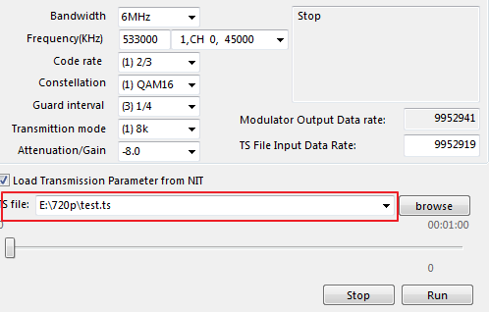
- Select a TS file,
  - TsPlayerControl setfile “E:\720p\test.ts”
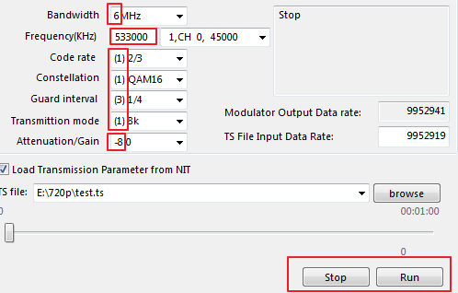
- Set the transmission parameters
  - TsPlayerControl.exe set 6 533000 1 1 3 1 0
- Start TSPlayer transmission
  - TsPlayerControl.exe run
- Stopt TSPlayer transmission
  - TsPlayerControl.exe stop

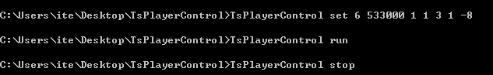

Commands:

- tx? : check if Tx device is presented.
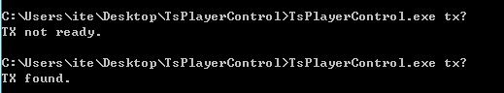

- setisdbt: set the configuration for ISDB-T
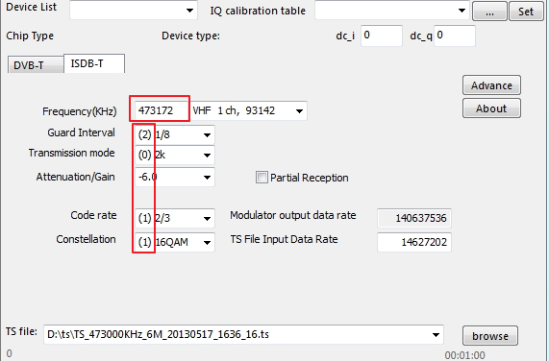
- setmod: switch between DVB-T and ISDB-T.
To DVB-T:

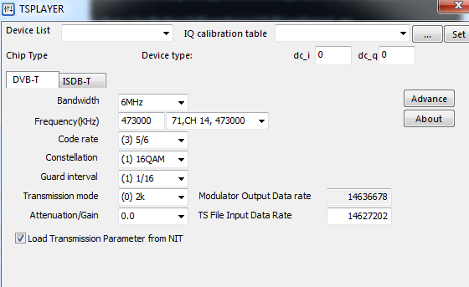
To ISDB-T:

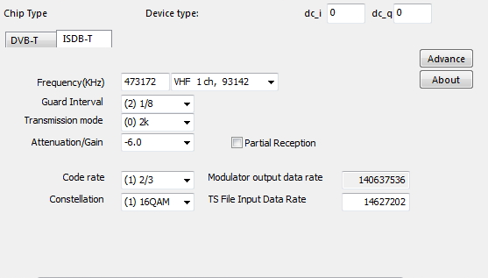

- setfile: change the TS file
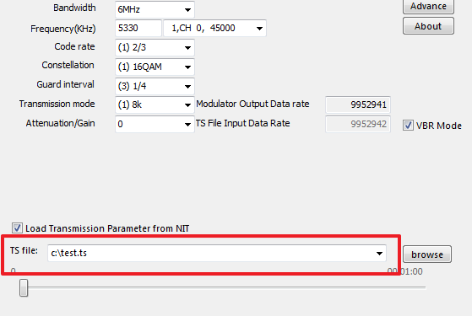
- setvbr: set or cancel VBR mode.
  - 1 to set VBR mode, 0 to cancel.

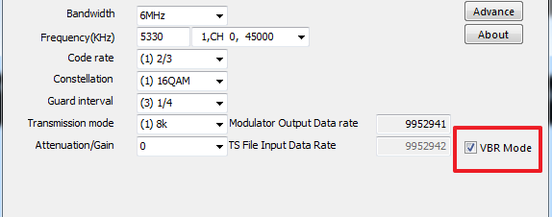

- Setfilerate: set TS File Input Data Rate.
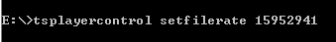
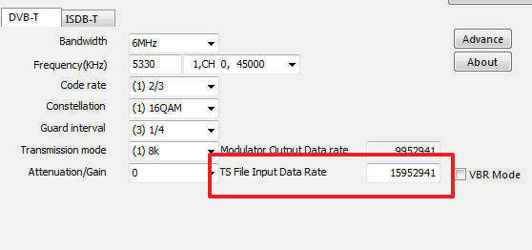

- wait: wait for a specified interval (in ms).
- Waittill: wait until the specified time (yyyy:mm:dd:hh:mm:ss).
